Instructions to Claim CME Credit for HVI Grand Rounds Presentations

- Use the QR code displayed at end of the presentation to access the CME credit page
- Follow the onscreen prompts to either add an CE account with USF Health (see instructions below), or, if requested, update the one you already have
- Once your account is up to date, you will take a short activity evaluation
- At that point, you will be asked to attest to your credit
- Save your certificate or send it to yourself in an email

Creating a CE Account with USF Health

Go to health.usf.edu/cpd and click My CE Portal located in the menu bar. Then click Sign In.

- Enter your email address and click Create Account.

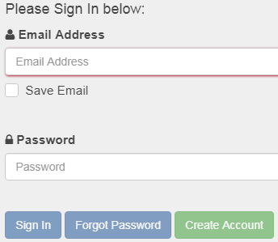

- Enter your last name and birth date to make sure you do not already have an account and then click Submit.

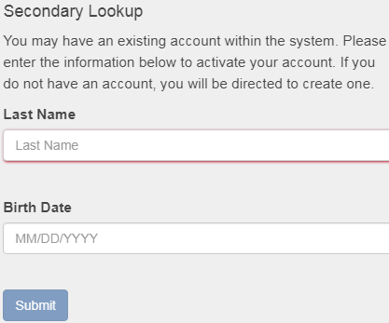

- Click Continue to set up account.

- Complete your online profile by filling in all fields marked with a red asterisk and then click Save Profile. Please make note of your email address and password. You will need them for future access.

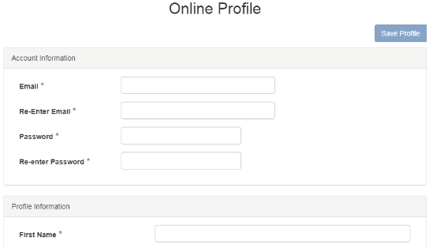

- Your account has been created. You may now view continuing education opportunities, register for programs, complete evaluations, print/view certificates and transcripts, etc.

